**Stock Reservations in Magento 2 Multi-Source Inventory (MSI)**

**What is Magento MSI?**

* **MSI (Multi-Source Inventory)** is a feature introduced in Magento 2.3 that allows merchants to manage their stock across multiple warehouses or sources.
* Before MSI, Magento only had a single inventory system, but with MSI, you can manage inventory from different locations and assign these stocks to websites or stores.

**Stock Reservations in Magento MSI**

* **Stock reservations** are an important concept in MSI.
* They help to track stock items that have been ordered but not yet shipped.
* This prevents the overselling of products, especially in high-demand environments where multiple customers might try to buy the same product at the same time.
* In simple terms, stock reservations ensure that once a customer places an order, the system "reserves" the stock for that order until it is either fulfilled or canceled.
* This reservation system provides accurate stock levels to other customers browsing the store.

**Why Are Stock Reservations Needed?**

* In the eCommerce world, when a customer places an order, they expect that the product is available and will be shipped.
* If there are many customers trying to order the same product, stock reservations help in

* **Preventing Overselling:**

Stock reservations prevent the same product from being sold to multiple customers when there’s only one unit left.

**\*Ensuring Accurate Inventory Display:**

Other customers will see the correct inventory level, factoring in the orders that are not yet fulfilled.

**\* Handling Cancellations:**

If an order is canceled, the reservation is removed, and the stock becomes available again.

**How Stock Reservations Work in Magento MSI**

**Order Placement:**

* When a customer places an order, Magento does not immediately deduct the stock from the inventory.
* Instead, a **reservation** is created, meaning the stock is marked as “reserved” but is still technically available in the inventory system.

**Stock Reservation Entry:**

* A record is added to the inventory_reservation table. This table stores information about all stock reservations.
* The record includes data like:
* SKU (Stock Keeping Unit) of the product
* Quantity reserved
* Order ID related to the reservation
* Stock ID (related to the source or warehouse)

**Order Shipment:**

* When the order is shipped, the reserved quantity is deducted from the source inventory (the physical warehouse).

**Order Cancellation:**

* If an order is canceled, the reservation is cleared, and the stock is made available for other customers.

**Key Components of Stock Reservations in Magento MSI**

#### **Reservations Table (inventory_reservation)**

* This table stores all the reservation records. Each row represents a reserved stock item.

**Important Fields:**

* **Reservation ID:** Unique ID for the reservation.
* **Stock ID:** Identifies the source (warehouse).
* **SKU:** The product for which the reservation is made.
* **Quantity:** The quantity of the product reserved.
* **Metadata:** Additional information, usually the order ID.

**Stock Deduction**

* Stock is not physically reduced from the inventory until the order is shipped. Until then, it remains in the reservation.

**Source Management**

* In MSI, each warehouse or store location is treated as a "source." Reservations track where the stock is coming from, and which source is involved in fulfilling the order.

**Salable Quantity**

* Magento shows a **"Salable Quantity"** in the product listings.
* Salable Quantity = Available Stock - Reservations
* This is the quantity that customers can see and purchase, taking reservations into account.

**Basic Example of Stock Reservations Flow**

**simple scenario:**

* **Product**: T-Shirt
* **Initial Stock**: 10 units
* **Customer 1**: Orders 5 units
  + A reservation of 5 units is created in the inventory_reservation table.
  + The Salable Quantity becomes 5 units (10 - 5).
* **Customer 2**: Orders 3 units
  + Another reservation of 3 units is created.
  + The Salable Quantity becomes 2 units (10 - 5 - 3).
* **Customer 1's Order** is **Shipped**:
  + The reserved 5 units are deducted from the stock.
  + The stock level now becomes 5 units.
* **Customer 2's Order** is **Canceled**:
  + The reservation is removed, and 3 units are added back to the Salable Quantity.
  + The Salable Quantity is now 5 units again.

**Advanced Concepts in Stock Reservations**

**Managing Multiple Sources (Warehouses)**

* Magento MSI allows you to manage multiple warehouses or sources.
* For each source, you can configure stock levels, shipping methods, and prioritize sources based on proximity to the customer.
* Stock reservations can be tracked across all sources, ensuring each source holds the correct stock information.

**Partial Shipments**

* If a customer orders multiple products and some are shipped, Magento will only deduct the shipped products from the stock. The rest remains reserved until it is fulfilled or canceled.

**Backorders**

* Magento allows **backorders**, meaning customers can order even if the stock is not available.
* In such cases, reservations are still created, and the backorder is fulfilled when the stock is replenished.

**Reservations for Guest and Logged-in Customers**

* Reservations work the same way for both guest users and logged-in users. As soon as the order is placed, the system will create a reservation regardless of whether the user is registered or not.

**Common Issues with Stock Reservations and How to Fix Them**

**Overselling of Products**

* Issue: Customers are able to buy more products than you have in stock.
* Cause: Reservations might not be set correctly.
* Fix: Check if reservations are being created and cleared properly.

**Stock Not Updating After Shipment**

* Issue: Stock levels remain the same even after an order is shipped.
* Cause: Reservation might not have been cleared.
* Fix: Check the inventory_reservation table to ensure the reservation is cleared after shipping.

**Canceled Orders Still Showing Reserved Stock**

* 1. Issue: Stock remains reserved even after an order is canceled.
  2. Cause: Reservation not cleared.
  3. Fix: Manually remove the reservation record or investigate any Magento cron job failures.
* Stock reservations in Magento MSI play a crucial role in ensuring accurate stock management, preventing overselling, and maintaining customer trust.
* From basic reservation creation when an order is placed, to more advanced multi-source inventory management, reservations provide an accurate and flexible way to handle inventory across multiple warehouses.
* Understanding how stock reservations work, and how they fit into the broader MSI system, helps you manage your stock efficiently and avoid common issues.

**How to check MSI functionality**

#### **Ensure Magento MSI is Installed and Enabled**

* php bin/magento module:status
* Check whether these modules are presented in your system
* Magento_Inventory
* Magento_InventoryApi
* Magento_InventoryAdminUi
* Magento_InventoryAdvancedCheckout
* Magento_InventoryBundleProduct
* Magento_InventorySales

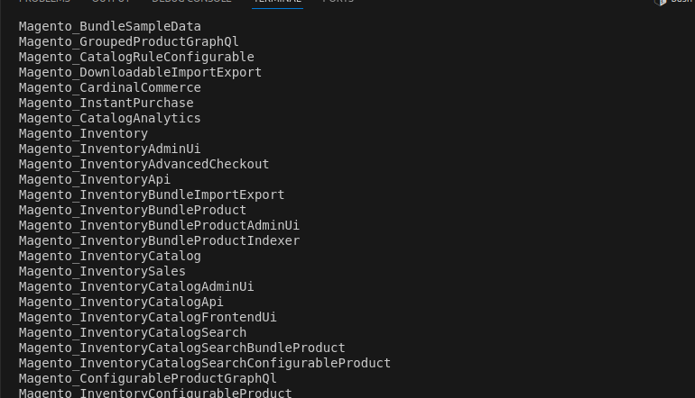

Configure Inventory Sources and Stocks

**Access Magento Admin Panel:**

* Log in to your Magento Admin.

**Add or Configure Sources:**

* Navigate to **Stores** > **Inventory** > **Sources**.
* Click **Add New Source** to create a new warehouse/source.
* Fill in the necessary details like **Name**, **Code**, **Country**, **Address**, etc.
* Save the source.

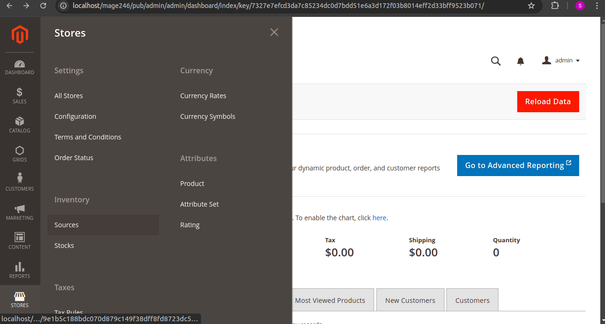

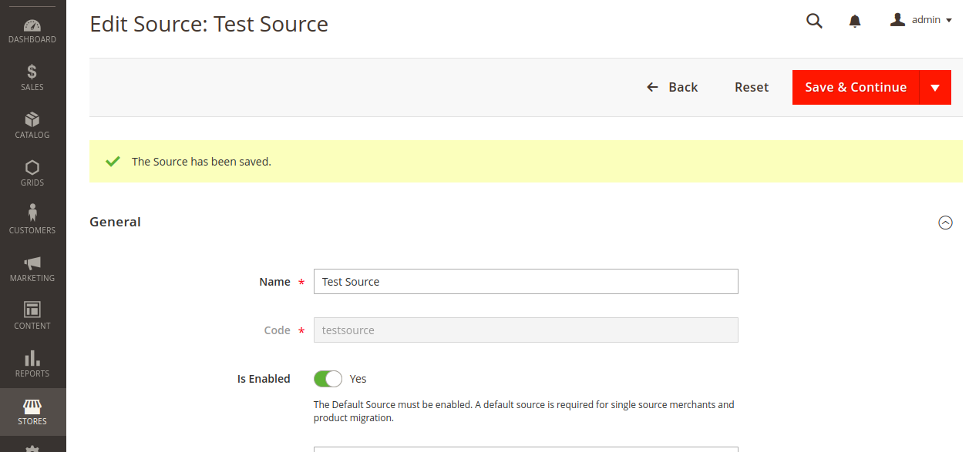

**Assign Products to Sources:**

* Go to **Catalog** > **Products**.
* Edit a product you want to assign to a source.
* Scroll down to the **Sources** section.
* Assign the desired quantity to each source.
* Save the product.

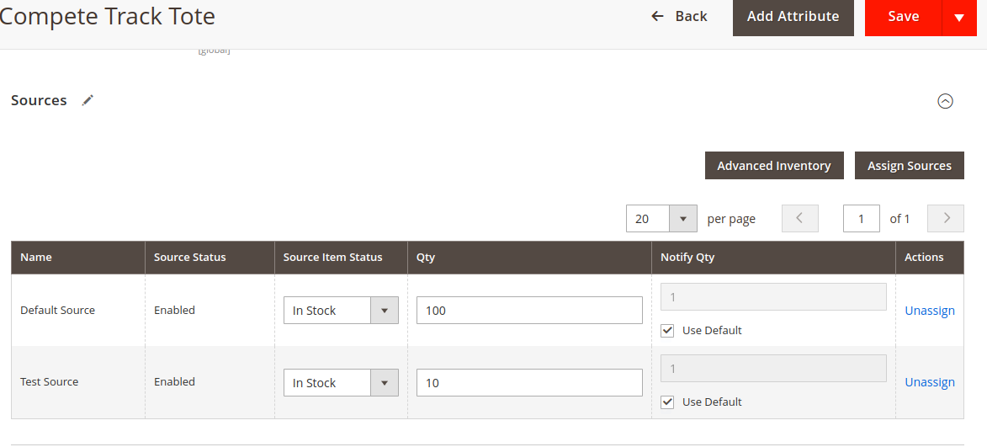

**Create or Configure Stocks:**

* Navigate to **Stores** > **Inventory** > **Stocks**.
* If you have multiple stocks, ensure each stock is linked to the correct sources.
* **Default Stock** is usually set up automatically, but you can create additional stocks if needed.
* Assign websites to stocks as necessary.
* Product stock options
* In stores/inventory/stocks
* We need to assign the created testsource with default website

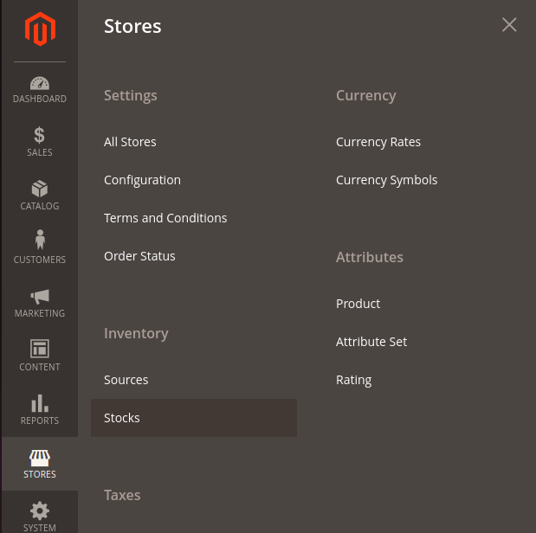

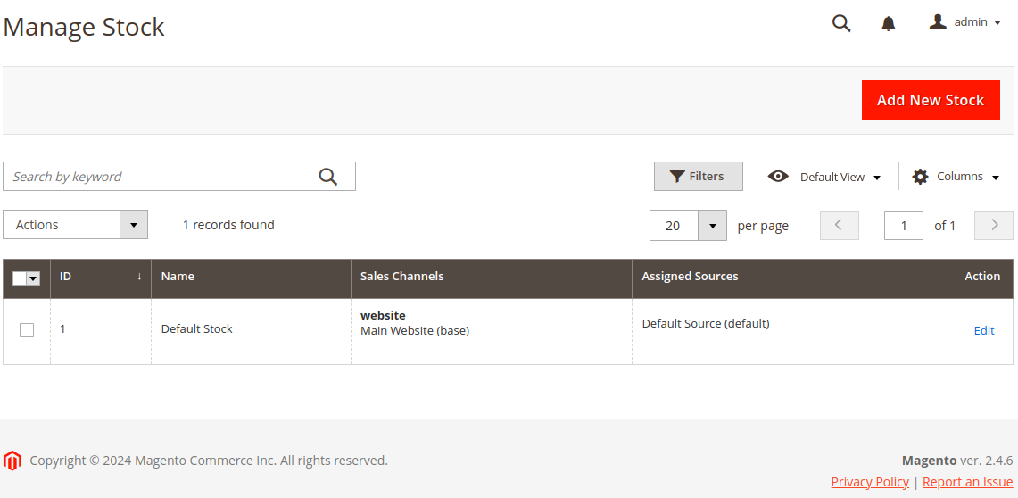

**Checked in inventory_reservation table**

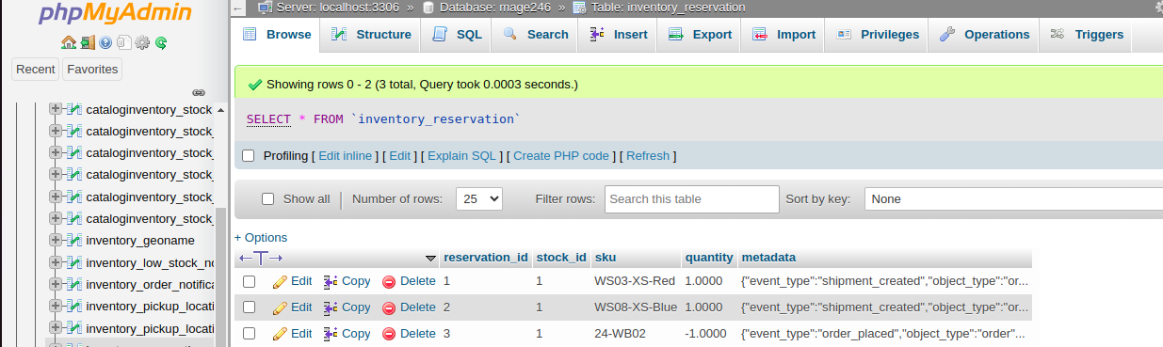

The third order is showing negative sign in the quantity it appears when the product is overselling  
  
I have didn’t assigned my website to the stock

In stores/inventory/stocks

We need to assign the created testsource with default website

**Advantages**

* **Prevents Overselling:**

Stock is reserved as soon as an order is placed, avoiding the risk of selling more than what's available.

* **Real-Time Stock Updates:**

The salable quantity is updated in real-time, ensuring accurate product availability is displayed on the storefront.

* **Supports Multiple Warehouses:**

It manages inventory across multiple locations, reserving stock from the best warehouse or source for each order.

* **Flexibility in Shipping:**

Separates order placement from shipping, so stock is held until the product is ready to ship, improving flexibility.

* **Manages Backorders:**

Allows handling of backorders by reserving future stock for customers when items are out of stock.

* **Syncs with Catalog Changes:**

Automatically syncs inventory changes with the product catalog to ensure accurate stock information.

* **Enhances Stock Accuracy:**

It tracks stock movements and reservations, leading to better inventory control.

* **Customizable for Different Sources:**

Can be customized for specific business needs, like handling inventory for dropshipping or external warehouses.

* **Helps During Stockouts:**

When stock is low, the system can reserve remaining units, ensuring customers still get accurate stock information.

* **Reduces Manual Work:**

Automates stock management tasks, reducing the need for manual adjustments and oversight.

**Disadvantages**

* **Complex System:**

Managing reservations can be complicated, especially for users unfamiliar with MSI.

* **Can Lead to Stock Issues:**

If not managed properly, it can create discrepancies between physical stock and salable quantity.

* **Requires Cron Jobs:**

Reservation processing relies on cron jobs, which need to be set up and monitored regularly to avoid failures.

* **Negative Stock Reservations:**

Sometimes, backorders or system issues can cause negative reservations, leading to confusion.

* **Impacts Performance:**

In high-traffic stores, real-time stock reservations may slow down performance, especially with large volumes.

* **Challenges with Cancellations:**

If orders are canceled, stock may not always be properly returned, leading to stock inaccuracies.

* **Requires Regular Monitoring:**

Admins need to check stock levels and reservations frequently to ensure everything is working correctly.

* **Custom Sources Need Extra Setup:**

If you use custom inventory sources, extra setup and maintenance may be needed to integrate properly.

* **Synchronization Issues:**

If not set up right, stock levels in different locations may go out of sync with actual inventory.

* **Learning Curve:**

Businesses need to spend time learning how MSI and stock reservations work to avoid mistakes or delays in orders.

---------------------------------------------------------------------------------------

**Description of this document**

* Magento's Multi-Source Inventory (MSI) system introduces **stock reservations** as a key feature to manage inventory across multiple sources (warehouses, stores, etc.).
* The reservation system works by temporarily reserving product quantities when an order is placed, before the actual shipment happens.
* ensures that stock is allocated correctly and helps in providing a more accurate **salable quantity** on the storefront.